**SESSION 1**

**Functional List**

**1.0 Session 1**

**1.1 Asset Catalogue**

1.1 Providing list of current assets

**1.2 Search Tool Bar**

2.1 Search Asset

**1.3 Search Parameters (Own Likings)**

3.1 Departments

3.2 Asset Groups

**1.4 Warranty Date Range**

4.1 Choosing to see the assets that have warranties

**1.5 Registering & Editing Assets**

5.1 Allowing clients to register new assets

5.2 Uploading pictures

5.3 Submit

5.4 Cancel

**1.6 Edit Button**

6.1 Modifying Details

**1.7 Asset Transfers**

7.1 Transfer assets between warehouses

**1.8 Transfer History**

8.1 Viewing list of previous asset

**1.9 Back Button**

9.1 Back to the “main menu

**Decomposition Diagram**

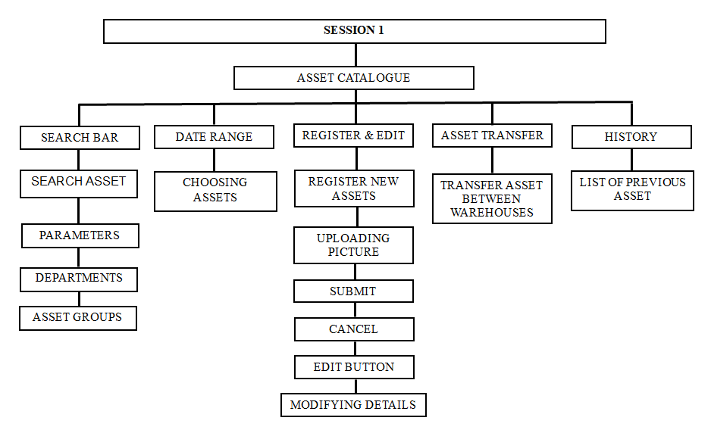

**Figure 1: Session 1 Diagram**

**FLOWCHART**